A System Dynamics Model of the Refugee Crisis
Part 2 - Influence Diagrams

How to Read the Influence Diagrams
We have developed two interrelated influence diagrams to describe many of the relationships involved in a refugee crisis. These influence diagrams express the relationships as items connected by causation arrows. A causation arrow means that a change in one item causes a change in another item. The arrow shows the direction of the change relationship. A change in the item at the tail of the arrow will cause a change in the item at the head of the arrow (i.e. one item will influence the other item). At the head of the arrows is a letter, either an 's' or an 'o'. If the letter at the head of the arrow is 's', this means that the change is in the 'same' direction. That is, if the item at the tail of the arrow goes up, then the item at the head of the arrow goes up and if the item at the tail of the arrow goes down, then the item at the head of the arrow goes down. Diagram 1 shows the influence relationships between various aspects of refugee movements between two countries. For example in diagram 1, there is an arrow from Food to Population with Enough Food that has a letter 's' at the head. This means the two values move in the 'same' direction. So if the amount of Food goes up, then the Population with Enough Food goes up and if the amount of Food goes down, then the Population with Enough Food goes down. If the letter at the head of the arrow is 'o', this means the change is in the 'opposite' direction. That is, if the item at the tail of the arrow goes up, then the item at the head of the arrow goes down and if the item at the tail of the arrow goes down, then the item at the head of the arrow goes up. Also in diagram 1, there is an arrow between Peacekeepers and Violence with a letter 'o' at the head of the arrow. This means the values move in the 'opposite' direction. That is, if the number of Peacekeepers goes up, the amount of Violence goes down and if the number of Peacekeepers goes down, the amount of Violence goes up.

A Diagram for the Movement of Refugees

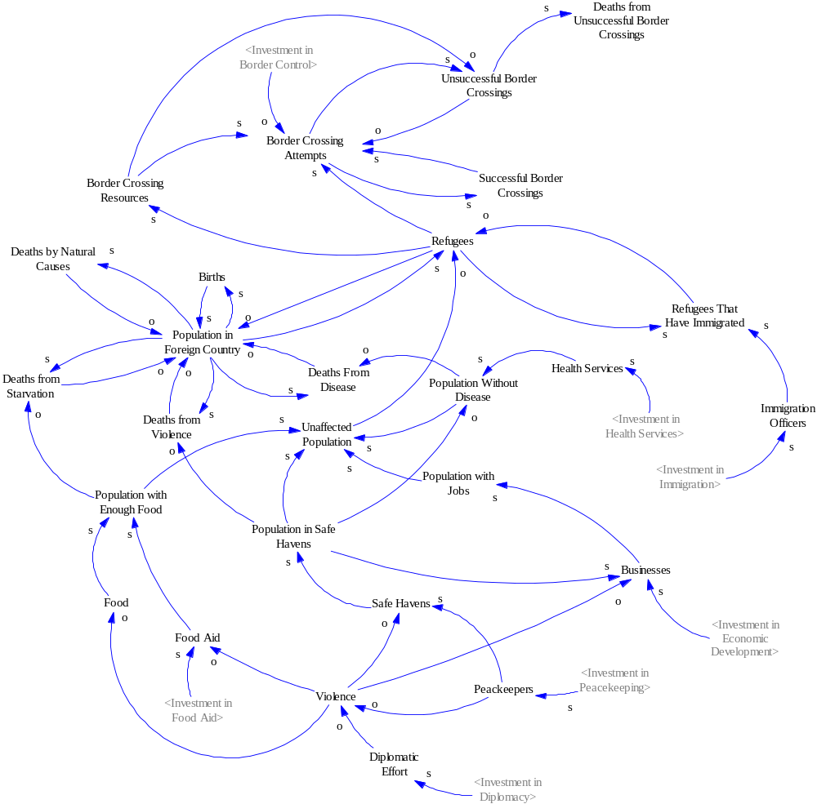

Diagram 1: The Movement of Refugees Between Two Countries

To analyze this diagram, we can see that the number of births increases the population in the foreign country and the population in the foreign country increases the number of births. So the number of Births influences the Population in the Foreign Country in the 'same' direction and the Population in the Foreign Country influences the Births in the 'same' direction.

The number of deaths by natural causes, starvation, violence or disease causes the population in the foreign country to decrease and if the population in the foreign country decreases, the number of deaths by natural causes, starvation, violence and disease decreases. So, the Deaths by Natural Causes, Deaths by Starvation, Deaths by Violence and Deaths by Disease influences the Population in the Foreign Country in the 'opposite' direction and the Population in the Foreign Country influences the Deaths by Natural Causes, the Deaths by Starvation, the Deaths by Violence and Deaths by Disease in the 'same' direction.

The number of deaths by starvation is based on the difference between the population in the foreign country and the population with enough food. If the population with enough food increases, then the deaths by starvation decreases. So, the Population with Enough Food influences the Deaths by Starvation in the 'opposite' direction.

The number of deaths by violence is based on the difference between the population in the foreign country and the population in safe havens. If the population in safe havens increases, then the deaths by violence decreases. So the Population in Safe Havens influences the Deaths by Violence in the 'opposite' direction.

The number of deaths by disease is based on the difference between the population in the foreign country and the population without disease. If the population without disease increases, then the deaths by disease decreases. So the Population Without Disease influences the Deaths by Disease in the 'opposite' direction.

The Population with Enough Food is based on the amount of food that the country can produce and the amount of food aid that the country can obtain from other countries. That is, it is influenced in the 'same' direction by the amount of Food and the amount of Food Aid. The amount of Food Aid is based on the Investment in Food Aid by other countries. However, violence can impede the ability of the food aid from getting to the people who need it. So, the amount of Food Aid is influenced in the 'same' direction by the amount of Investment in Food Aid and influenced in the 'opposite' direction by the amount of Violence. Similarly violence can reduce the amount of food that can be produced. So, Violence influences Food in the 'opposite' direction.

The Population without Disease is based on the amount of health services in the country and the Population in Safe Havens. If the Population in Safe Havens increases, it is assumed that disease will spread faster. That is, the Population Without Disease is influenced in the 'opposite' direction. If the amount of Health Services increases, the amount of disease will decrease. That is, the Population Without Disease is influenced in the 'same' direction. The amount of Health Services is based on the Investment in Health Services by other countries. That is, the Health Services is influenced by Investment in Health Services in the 'same' direction.

We assume that there is a certain amount of violence in the country caused by a civil war. When possible, peacekeepers from other countries can try to reduce the amount of violence. Also, other countries can try to reduce the amount of violence by using diplomatic means to solve the problems that are causing the civil war. So, the amount of Violence is influenced in the 'opposite' direction by the number of Peacekeepers and the amount of Diplomatic Effort. Both peacekeeping effort and diplomatic effort are related to the foreign policy of the other countries. So, the number of Peacekeepers is influenced in the 'same' direction by the Investment in Peacekeeping and the amount of Diplomatic Effort is influenced in the 'same' direction by the amount of Investment in Diplomacy.

The number of refugees is based on the relationship between the population in the foreign country and the population unaffected by famine, disease, war or poverty. The Population in the Foreign Country has an influence on the number of Refugees in the 'same' direction, whereas the Unaffected Population has an influence on the number of Refugees in the 'opposite' direction. In turn, as the number of refugees increases, the population in the foreign country decreases. So, the number of Refugees influences the Population in the Foreign Country in the 'opposite' direction.

The size of the unaffected population is determined by the amount of famine, disease, war and poverty. That is, it is influenced in the 'same' direction by the Population with Enough Food, Population without Disease, the Population in Safe Havens and the Population with Jobs.

The population unaffected by the civil war are assumed to be sheltered in areas that we will call safe havens. These safe havens are set up and protected by peacekeepers and are assumed to be threatened by the parties fighting in the civil war. That is, the Population in Safe Havens is influenced in the 'same' direction by the number of Safe Havens. The number of Safe Havens is influenced in the 'same' direction by the number of Peacekeepers and in the 'opposite' direction by the amount of Violence.

In the safe havens, the people can live a fairly normal life which includes conducting economic activity such as creating businesses and giving people jobs that reduce the amount of poverty in the country. The Population with Jobs in the country is influenced in the 'same' direction by the number of Businesses in the safe havens. Businesses can thrive when there are many people in the safe havens but they can be disrupted by the surrounding civil war. They can also be aided by investment by other countries in the economic development of the country. So, the number of Businesses is influenced in the 'same' direction by the Population in Safe Havens and in the 'opposite' direction by the amount of Violence, while they are influenced in the 'same' direction by the amount of Investment in Economic Development.

A certain number of refugees are allowed to immigrate into the new country but the speed with which their cases for immigration are decided is based on the limited number of immigration officers in the new country and the number of immigration officers is based on the investment that is put into the immigration organization in the new country. So, the number of Refugees That Have Immigrated is influenced in the 'same' direction by the number of Refugees and in the 'same' direction by the number of Immigration Officers. The number of Refugees That Have Immigrated decreases the number of Refugees. So, the Refugees That Have Immigrated influences the number of Refugees in the 'opposite' direction. That is, the more Refugees and the more Immigration Officers, the more Refugees That Have Immigrated but the more Refugees That Have Immigrated, the less Refugees. The number of Immigration Officers is influenced in the 'same' direction by the amount of Investment in Immigration.

We are primarily interested in the number of deaths caused by unsuccessful unconventional border crossings. If the immigration process is too slow or likely to be unsuccessful, the refugees may attempt an unconventional border crossing. A high number of successful unconventional border crossings might encourage the remaining refugees to attempt an unconventional border crossing. A high number of unsuccessful unconventional border crossings will cause a high number of deaths and might discourage future attempts by other refugees. So, we have divided the border crossings into successful border crossings and unsuccessful border crossings. We assumed unsuccessful border crossings lead to a certain number of deaths of the refugees that attempt them. All of the border crossings require resources. The more refugees in the country, the more pressure there will be to make border crossing resources available. We assume that if the border crossing resources are low, this will mean less unconventional border crossings are attempted but the border crossings that are attempted will be more dangerous and more likely to cause deaths.

So in our diagram, the number of Refugees influences the amount of Border Crossing Resources and the number of Border Crossing Attempts in the 'same' direction, and the amount of Border Crossing Resources influences the number of Border Crossing Attempts in the 'same' direction. The number of Border Crossing Attempts influences the number of Successful Border Crossings and the number of Unsuccessful Border Crossings in the 'same' direction. The number of Successful Border Crossings influences the number of Border Crossing Attempts in the 'same' direction while the number of Unsuccessful Border Crossings influences the number of Border Crossing Attempts in the 'opposite' direction. The number of Unsuccessful Border Crossings influences the number of Deaths from Unsuccessful Border Crossings in the 'same' direction. The number of Deaths from Unsuccessful Border Crossings is influenced in the 'opposite' direction by the amount of Border Crossing Resources.

So, we have two circular relationships. The more successful border crossings, the more refugees who are encouraged to attempt a border crossing and the more border crossings occur, and as a result there are more successful border crossings. However, the more border crossings attempted, the more unsuccessful border crossings and the more deaths from unsuccessful border crossings and the more refugees who would be discouraged from attempting a border crossing. So, the number of border crossings attempted would go down and the number of unsuccessful border crossings would go down. However, as the number of unsuccessful border crossings goes down, more refugees would be encouraged to attempt a border crossing and the number of border crossings would go up again.

The last thing we will consider in this diagram is the amount of border control. To be effective, increasing the amount of border control would need to decrease the number of border crossings attempted. So, Investment in Border Control must influence the Border Crossing Attempts in the 'opposite' direction.

A Diagram of the Allocation of Investment in Humanitarian Relief
We assume that the Investment Available is based on the number of vulnerable people, that is, the Population in the Foreign Country minus the Unaffected Population. The Available Investment is influenced in the 'same' direction by the Population in the Foreign Country and in the 'opposite' direction by the Unaffected Population.

The Available Investment is then allocated to the various types of relief: Food Aid, Health Services, Peacekeeping, Diplomacy, Immigration, Economic Development and Border Control. The investment in these relief efforts is influenced in the 'same' direction by the Available Investment and in turn, the Investment in Food Aid, Health Services, Peacekeeping, Diplomacy, Immigration, Economic Development and Border Control will reduce the Available Investment. Therefore, they influence Available Investment in the 'opposite' direction.

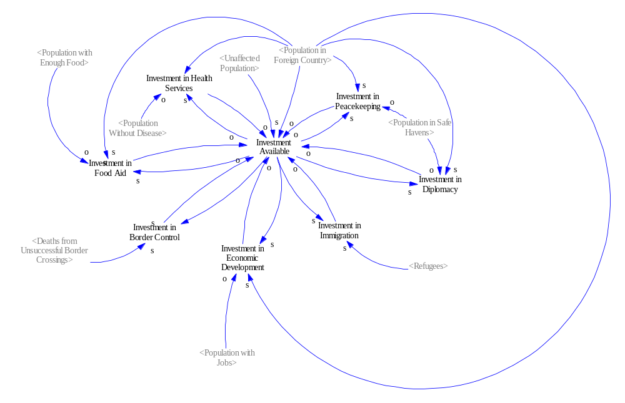
Diagram 2: The Allocation of Investment in the Relief Effort

We have a circular relationship, in that increased Available Investment will lead to increased Investment in Food Aid, Investment in Health Services, Investment in Peacekeeping, Investment in Diplomacy and Investment in Economic Development. These allocations will increase the Population with Enough Food, the Population without Disease, the Population in Safe Havens and the Population with Jobs respectively which, in turn, will increase the Population Unaffected by famine, disease, war and poverty which will reduce the pressure to increase the Available Investment.

The Investment in Food Aid is determined by the Population in the Foreign Country minus the Population with Enough Food. So, the Investment in Food Aid is influenced by the Population in the Foreign Country in the 'same' direction and by the Population with Enough Food in the 'opposite' direction. Recall from diagram 1, that the Investment in Food Aid influences Food Aid in the 'same' direction which influences the Population with Enough Food in the 'same' direction. So, we have a circular effect. The more Investment in Food Aid, the more Food Aid and the greater the Population with Enough Food but the greater the Population with Enough Food, the less the Investment in Food Aid.

The Investment in Health Services is determined by the Population in the Foreign Country minus the Population without Disease. So, the Investment in Health Services is influenced by the Population in the Foreign Country in the 'same' direction and by the Population without Disease in the 'opposite' direction. Recall from diagram 1, that the Investment in Health Services influences Health Services in the 'same' direction which influences the Population without Disease in the 'same' direction. So, we have another circular effect. The more Investment in Health Services, the more Health Services and the greater the Population without Disease but the greater the Population without Disease, the less the Investment in Health Services.

Both the Investment in Peacekeeping and the Investment in Diplomacy are determined by the Population in the Foreign Country minus the Population in Safe Havens. That is, the Investment in Peacekeeping and the Investment in Diplomacy are influenced in the 'same' direction by the Population in the Foreign Country and influenced in the 'opposite' direction by the Population in Safe Havens. Again, we have circular relationships. Increasing the Investment in Peacekeeping will increase the number of Peacekeepers which, in turn, will increase the number of Safe Havens. The increased number of Safe Havens will increase the Population in Safe Havens which will reduce the pressure to invest in peacekeeping. Similarly, an increasing Investment in Diplomacy will cause an increase in Diplomatic Effort which will decrease the amount of Violence which in turn will increase the number of Safe Havens and thereby the Population in Safe Havens which will reduce the pressure to invest in diplomacy.

The more refugees, the more investment in immigration that is demanded. So, the Investment in Immigration is influenced by the number of Refugees in the 'same' direction. Here the circular relationship means that the Investment in Immigration will cause an increase in the number of Immigration Officers and speed up the process of immigration for refugees which will decrease the number Refugees and thereby reduce the pressure to invest in immigration.

The Investment in Economic Development is based on the Population in the Foreign Country minus the Population with Jobs. That is, the Population in the Foreign Country influences the Investment in Economic Development in the 'same' direction and the Population with Jobs influences the Investment in Economic Development in the 'opposite' direction. The circular relationship here is that the increased Investment in Economic Development will cause an increase in the number of Businesses which will increase the Population with Jobs which will reduce the pressure to invest in economic development.

Finally, we have Investment in Border Control. Investment in Border Control is influenced by the number of Deaths from Unsuccessful Border Crossings in the 'same' direction. The circular relationship is that Investment in Border Control will try to reduce the number of Border Crossing Attempts which reduce the number of Unsuccessful Border Crossings which will reduce the number of Deaths from Unsuccessful Border Crossings which will reduce the pressure to invest in border control.

Discussion
From the discussion of the diagrams above, we can see that the refugee crisis is dominated by balancing feedback loops. Therefore, when we develop the quantitative System Dynamics model in the next part of this study, we can expect the system to reach an equilibrium after a certain period of time. However, because of delays in the humanitarian relief effort, the situation will probably become worse before it becomes better. Investments in border control may be able to reduce the number of deaths from unsuccessful unconventional border crossings but although very visible, these deaths are just the tip of the iceberg. They are vastly outnumbered by deaths from famine, disease and violence. We believe that the overall goal of reducing the total number of deaths caused by the crisis will be most effectively achieved by a rapid response by the other countries to reduce or eliminate the level of violence in the foreign country. Reducing the level of violence will reduce the likelihood of a famine, will increase the number of safe havens and ensure that the population can develop their economy effectively to create jobs. Increasing the number of safe havens will reduce the crowding in the safe havens and prevent the rapid spread of disease. All of these factors (food security, physical safety, health and jobs) will work together to alleviate the refugee crisis in the foreign country once the level of violence is reduced. The level of violence is affected by the response of the other countries in terms of peacekeeping and diplomacy. Diplomacy efforts can be mobilized quickly whereas peacekeeping would be expected to take a number of months to organize. Investments in food aid, health services, border control and immigration are necessary short-term responses to the refugee crisis until the level of violence is reduced. The investment in economic development aid is a necessary long-term response that will have a positive impact on the foreign country in that the population will not have to leave to create a better life for themselves.

So the next step in this study is to develop a quantitative System Dynamics model using the special-purpose programming language Vensim. With this Vensim model, we should be able to create a simulation that reveals at least one way the refugee crisis could be resolved through the effective allocation of humanitarian aid in the short-term and in the long-term. This will be followed by the conversion of the quantitative Vensim model into the general-purpose language Fortran for detailed sensitivity analysis using design of experiments and for conducting a minimization process on the number of avoidable deaths caused by the refugee crisis. It is expected that using the Fortran version of the quantitative model will be able to generate many possible solution paths to the refugee crisis which might be then evaluated for ease of implementation.

